TDR 165 Meeting Room Booking Form
Date of Event | Time of Event
Please use separate booking form for each date you are booking. | Please remember to include any time you may need to set up and clear away.
Name of Event (if applicable)
Contact Name | Full Billing Address
Organisation
Telephone Number
Email Address
Name of Meeting host if Different from above

Number of people attending:
We will allocate you a room that is best suited to your needs according to availability.
We have Five meeting rooms that can accommodate the following numbers of people:
Room | Number of people | Half day | Full Day
Quality Room | 3 | £50.00 + VAT | £90.00 + VAT
Innovation Room | 10 | £100.00 + VAT | £180.00 + VAT
Ambition Room | 12 | £100.00 + VAT | £180.00 + VAT
Board Room | 8 | £140.00 + VAT | £240.00 + VAT
Large Conference Room | 20 | £160.00+ VAT | £300.00 + VAT

* The morning session is from 08:30am-12pm & the afternoon session is from 12:30pm-4:30pm. Should you require alternate times, please contact us to discuss this further.
Please note that reception doesn’t open until 08:30 and therefore if you wish to arrive before this time you must explicitly state this in your e-mail when sending over the booking form so that arrangements can be made.
Equipment Required (Please tick)
- Wi-Fi Access
- Flipchart & Accessories
- Projector & Screen
*Please note that Quality room is not equipped with a projector screen.
Room layout to set up by visitors
Refreshments not available
Parking
Please note that for all attendees bringing a vehicle must display a parking permit which can be collected at reception or can be sent via email before the event date.
Please see parking map below. We currently have the spaces in orange & blue available. It is preferable that you park in the orange spaces, but if those spaces are full than please park in blue.
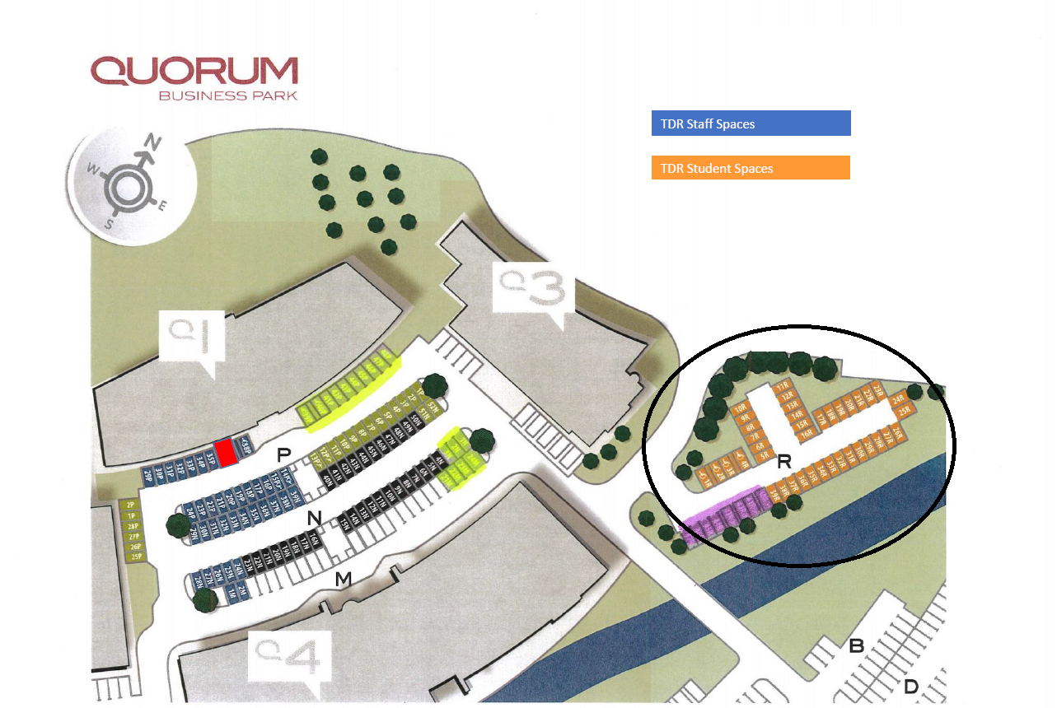

☐ I have read the terms and conditions below and agree to be bound by these.
(Please tick)
PLEASE NOTE: Signature must be scanned and not typed

Signed ……………………………………………… Print Name
Date
Please return the form to Accounts, TDR Training, Q1 Quorum Business Park, Benton Lane, Newcastle upon Tyne, NE12 8EX
Email: accounts@tdrtraining.co.uk
Please note that unsigned forms will not be accepted.

Terms & conditions of Room Hire:
Room hire opening times
Monday – Friday 08:30 – 16:30
Saturday CLOSED
Sunday CLOSED

Room and facilities
In these conditions of hire:
“The Hirer” means the person signing the contract for hire. If you are not the person leading the event, please can this be signed by the event leader in order for them to know the T&C’s.
“The premises” means the building or part of the building booked and referred to in the contract.
The hirer is responsible for the conduct and behaviour of all the people attending their event. This includes making sure that there is a register available to the reception area in case of an emergency.
The hirer shall take good care of and shall not cause any damage to the facilities.
TDR Training will not be held responsible for any of the attendee’s belongings. We ask that the hirer can make sure all of the belongings are kept in the room that they are using and not to leave their items at any other resting point.
We would like to make sure that our facilities remain clean at all times, therefore we ask that after breaks or lunch all rubbish and dirty cups/glasses are left at the resting point for them to be cleared away.
If you have requested additional technical items from TDR, we ask that these are handed back to the reception area before you leave.
Alcohol or drugs are not allowed onto or to be consumed on these premises.
The hirer will make sure that the room they are using is left tidy before departure. Including all empty glasses/cups being left at the resting point at 3pm Mon-Thu and 2pm Fri. If there are cups still in the room after this time, a member of staff may interrupt to collect them.
The hirer shall, during the period of hire be responsible for keeping the premises safe, making sure that there is no obstruction to enter and exit the room.
Health & Safety
All guests are required to sign in and out of the premises so everyone can be accounted for in case of an emergency. The person hosting the event will be shown the closes fire exits and TDR assembly point and will inform delegates.
If you have any enquiries as to any other reason our office may close, please contact us on 0191 491 1505
Disabled Access and Facilities
TDR is fully accessible and has wheelchair access to our meeting rooms via a lift. A disabled toilet is located on the same floor as all meeting rooms.

Booking and Payment
Following an enquiry or provisional booking, a booking form will be sent to the customer. The meeting room(s) will be held for a period of 7 days. If the form is not returned or the booking is no longer required, the room will be released. Once the booking form has been returned then the cancellation policy below comes into effect.
An invoice will be sent to the customer 15 days before room hire, payment to be made before room hire commences. Failure to pay might cause cancellation of the booking.
Cancellation
The hirer must notify TDR as soon as cancellation is required.
Groups | Information
Groups/Events from 1 to 10 person(s) | Cancellation of the reservation can be made free of charge up to 48 hours before the event schedule.
Groups/Events from 11 to 20 person(s) | Cancellation of the reservation can be made free of charge up to 72 hours before the event schedule.

Charges may apply if the room(s) are not cancelled within the times given above.
Non-cancelled rooms if a guest does not show up for the room hire as per the booking, full charges still apply.
Indemnity
The hirer of the room shall keep TDR notified of:
- Any loss or damage to the property
- Any accidents which occur on the premises, particularly any personal injuries
The hirer accepts all risks of any kind in respect of personal injury, loss or damage to the property and TDR accepts no liability in respect of any such risk.
Please be aware that TDR have the right to cancel or to terminate any room hire.

This form was issued in August 2020 and all prices and terms and conditions are subject to future review and change.

